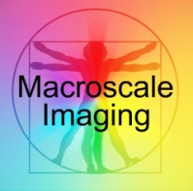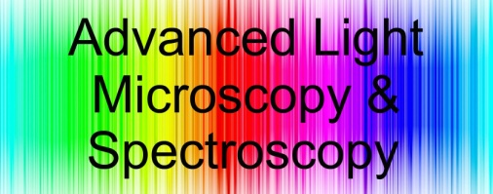

**Advanced Light Microscopy/Spectroscopy Laboratory & Macroscale Imaging Laboratory**

**SAFETY & EMERGENCY CONTACT #’s**

* MSDS and SOPs are found on the desktop of the computer in front of B145A in the main ALMS Lab. Username: default (no password)
* Please bring your own lab coat if you need to use one. Ask lab personnel if you need one for emergency use.
* Injury Emergencies (from campus phone) 911
* UCLA Police Department x 51491

or 310-825-1491

* UCLA Emergency Room x 52111
* Occupational Health x 56771
* Environmental Health & Safety Hotline x 59797
* Chemical Waste Hotline x 61887
* UCLA Facilities Trouble Desk x 59236
* EH&S (General) x 55689
* Radiation Safety (EH&S) x 56995
* Biosafety (EH&S) x 53323